Weather Data Comparison Report: NASA Power to Chirps v3.0
Analysis Period: Full Year 2020 (January - December)
Geographic Coverage: -35°S to 20°N, -20°W to 50°E

- Grid Cell Coverage and Resolution

- Total Grid Cells Analyzed: 12,543 cells
- Grid Dimensions: 1,11 latitude points × 113 longitude points
- Spatial Resolution: 0.5°
- Geographic Extent:
  - Latitude: 35°S to 20°N (spanning 55 degrees)
  - Longitude: 20°W to 50°E (spanning 70 degrees)
- Data Completeness: 100% valid data coverage (no missing cells)
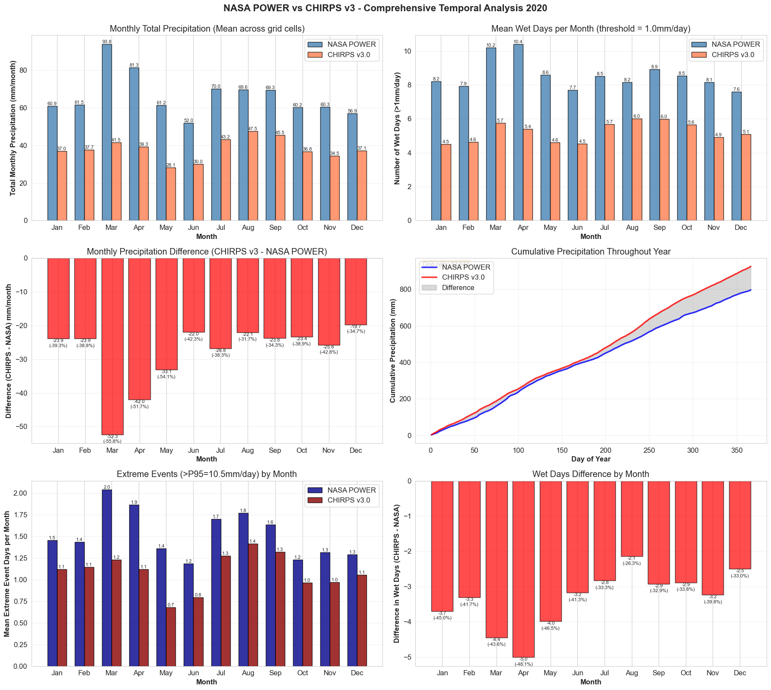

3. Monthly Breakdown: Where the Differences Matter Most
Detailed Monthly Comparison
Here's a month-by-month breakdown showing precipitation totals, differences, and wet days for both versions:
Month | NASA Power (mm) | v3 Total (mm) | Difference | % Change
January | 60.9 | 37.0 | -23.9 | -39.3%
February | 61.5 | 37.7 | -23.9 | -38.8%
March | 93.8 | 41.5 | -52.3 | -55.8%
April | 81.3 | 39.3 | -42.0 | -51.7%
May | 61.2 | 28.1 | -33.1 | -54.1%
June | 52.0 | 30.0 | -22.0 | -42.3%
July | 70.0 | 43.2 | -26.8 | -38.3%
August | 69.6 | 47.5 | -22.1 | -31.7%
September | 69.3 | 45.5 | -23.8 | -34.3%
October | 60.2 | 36.8 | -23.4 | -38.9%
November | 60.3 | 34.5 | -25.8 | -42.8%
December | 56.9 | 37.1 | -19.7 | -34.7%
Table 1Monthly Precipitation
Key Monthly Insights

Highest Precipitation Months:
- NASA POWER: March (93.8 mm), April (81.3 mm), and July (70.0 mm)
- CHIRPS v3.0: August (47.5 mm), September (45.5 mm), and July (43.2 mm)

Lowest Precipitation Months:
- NASA POWER: June (52.0 mm), December (56.9 mm), and October (60.2 mm)
- CHIRPS v3.0: May (28.1 mm), June (30.0 mm), and November (34.5 mm)

Largest Absolute Difference:
- March showed the greatest gap: 52.3 mm difference (NASA POWER reported 93.8 mm while CHIRPS v3.0 reported 41.5 mm)

Smallest Relative Difference:
- August had the closest agreement: 31.7% difference (NASA: 69.6 mm, CHIRPS: 47.5 mm)

Month | NASA POWER (days) | CHIRPS v3.0 (days) | Difference (days) | Change (%)
January | 8.2 | 4.5 | -3.7 | -45.0%
February | 7.9 | 4.6 | -3.3 | -41.7%
March | 10.2 | 5.7 | -4.4 | -43.6%
April | 10.4 | 5.4 | -5.0 | -48.1%
May | 8.6 | 4.6 | -4.0 | -46.5%
June | 7.7 | 4.5 | -3.2 | -41.3%
July | 8.5 | 5.7 | -2.8 | -33.5%
August | 8.2 | 6.0 | -2.1 | -26.3%
September | 8.9 | 6.0 | -2.9 | -32.9%
October | 8.5 | 5.6 | -2.9 | -33.8%
November | 8.1 | 4.9 | -3.2 | -39.8%
December | 7.6 | 5.1 | -2.5 | -33.0%
Table 2 Monthly Wet Days

Wet Days Insights
Key Findings:
- NASA POWER consistently reports more wet days across all months
- On average, NASA POWER shows 8.6 wet days per month per grid cell
- CHIRPS v3.0 shows an average of 5.2 wet days per month per grid cell
- The difference ranges from 2.1 days (August) to 5.0 days (April)

Wettest Months by Frequency:
- NASA POWER: April (10.4 days), March (10.2 days), September (8.9 days)
- CHIRPS v3.0: August (6.0 days), September (6.0 days), July (5.7 days)

4. Seasonal Patterns: Understanding Climate Zones
Four-Season Comparison
Here's how the two versions compare across the traditional meteorological seasons:

December-January-February - Northern Dry / Southern Wet
- NASA POWER Total: 179.3 mm
- CHIRPS v3.0 Total: 111.7 mm
- Difference: -67.5 mm (-37.7%)
- Wet Days: NASA 23.7 days vs CHIRPS 14.2 days (difference: -9.5 days)

March-April-May - Transition Season
- NASA POWER Total: 236.4 mm (wettest season for NASA)
- CHIRPS v3.0 Total: 108.9 mm
- Difference: -127.5 mm (-53.9%) (Largest seasonal difference)
- Wet Days: NASA 29.2 days vs CHIRPS 15.7 days (difference: -13.4 days)

June-July-August - Northern Wet / Southern Dry
- NASA POWER Total: 191.6 mm
- CHIRPS v3.0 Total: 120.7 mm (wettest season for CHIRPS)
- Difference: -70.8 mm (-37.0%)
- Wet Days: NASA 24.3 days vs CHIRPS 16.2 days (difference: -8.2 days)

September-October-November - Transition to Wet
- NASA POWER Total: 189.8 mm
- CHIRPS v3.0 Total: 116.8 mm
- Difference: -73.0 mm (-38.5%)
- Wet Days: NASA 25.6 days vs CHIRPS 16.5 days (difference: -9.1 days)

Seasonal Summary
March-April-May shows the most significant disagreement between the two datasets, with NASA POWER reporting 53.9% more precipitation than CHIRPS v3.0

5. Extreme Events and Precipitation Thresholds
Understanding Extreme Rainfall
We analyzed extreme precipitation events using statistical thresholds to understand how the two versions differ in capturing heavy rainfall:
Threshold | Definition | NASA Power | v3 Threshold Value
P90 | Top 10% of daily rainfall | 1,842.4 mm/year | 1,477.7 mm/year
P95 | Top 5% of daily rainfall | 2,199.7 mm/year | 1,706.2 mm/year
P99 | Top 1% of daily rainfall | 3,175.9 mm/year | 2,307.9 mm/year

Daily Extreme Events (>P95 = 10.5 mm/day): The analysis examined daily extreme precipitation events throughout the year:
- Both datasets show similar patterns with peaks in March-April and July-August
- NASA POWER consistently shows more extreme event days per month (ranging from 1.2 to 2.0 days per month)
- CHIRPS v3.0 shows fewer extreme days (ranging from 0.7 to 1.4 days per month)
Dry vs Wet Conditions:
Dry Conditions (≤166 mm/year):
- NASA POWER Mean: 71.4 mm/year
- CHIRPS v3.0 Mean: 18.1 mm/year
- Difference: -53.2 mm/year (-74.6%)

Wet Conditions (≥1,249 mm/year):
- NASA POWER Mean: 1,870.1 mm/year
- CHIRPS v3.0 Mean: 1,195.9 mm/year
- Difference: -674.2 mm/year (-36.1%)

